**AWS Route 53**

Amazon Route 53 is a scalable and highly available Domain Name System (DNS) web service offered by Amazon Web Services (AWS). It is designed to provide reliable and cost-effective domain registration, DNS routing, and health checking of resources within AWS and beyond.

**DNS Server:**

A DNS (Domain Name System) server is a crucial component of the internet's infrastructure. It is responsible for translating human-friendly domain names, such as "[www.example.com](http://www.example.com/)," into the IP addresses that computers use to identify and communicate with each other on the internet. In simpler terms, DNS servers help user’s access websites and other resources using easy-to-remember domain names instead of having to remember complex numerical IP addresses

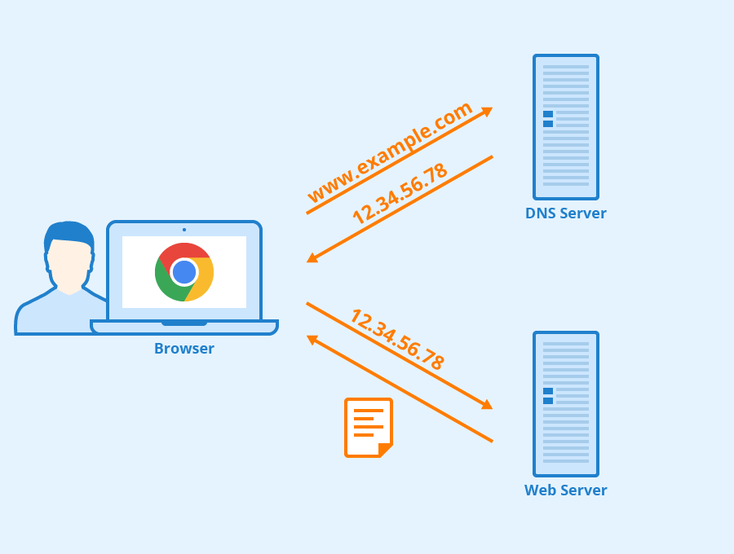

**Key features of AWS Route 53:**

**1. Domain Registration:** Route 53 allows you to register and manage domain names. You can purchase new domain names directly from Route 53 or transfer existing domain names from other registrars.

**2. DNS Management:** Route 53 provides DNS management capabilities, allowing you to create and manage DNS records for your domain. These records include A records (IPv4 addresses), AAAA records (IPv6 addresses), CNAME records (aliases), MX records (mail servers), TXT records (text-based information), and more.

**3. Routing Policies:** Route 53 offers several routing policies that determine how traffic is distributed to your resources. These include:

- Simple Routing: Directs traffic to a single resource based on the configured record.

- Weighted Routing: Distributes traffic across multiple resources based on assigned weights.

- Latency-Based Routing: Routes traffic to the resource with the lowest latency from the user's location.

- Geolocation Routing: Routes traffic based on the geographic location of the user.

- Failover Routing: Redirects traffic to a standby resource in case the primary resource becomes unavailable.

**4. Health Checks:** Route 53 allows you to configure health checks for your resources. These health checks monitor the availability of your resources and automatically adjust DNS routing based on their health status. This helps ensure high availability and failover.

**5. Traffic Flow:** AWS Route 53 Traffic Flow is a visual tool that helps you define how to route traffic to your resources. It allows you to create complex routing configurations using a visual editor.

**6. Alias Records:** Alias records are a Route 53-specific feature that allows you to map a DNS record to an AWS resource (such as an Elastic Load Balancer, CloudFront distribution, or an S3 bucket) using the resource's AWS-assigned DNS name. This provides better performance and allows for seamless updates to resource endpoints.

**7. Private DNS:** Route 53 supports Private DNS, which enables you to resolve domain names within your Virtual Private Cloud (VPC) without exposing them to the public internet.

**8. Domain Name Transfers:** You can transfer domain names from other registrars to Route 53, allowing you to manage all your domains in one place within the AWS Management Console.

**9. Integration with Other AWS Services:** Route 53 seamlessly integrates with various AWS services, such as Amazon S3, Elastic Load Balancing, AWS CloudFront, and more, making it easier to configure and manage DNS records for these resources.

**10. Global Network:** Route 53 operates on a global network of DNS servers strategically distributed around the world, which helps improve the speed and reliability of DNS queries.

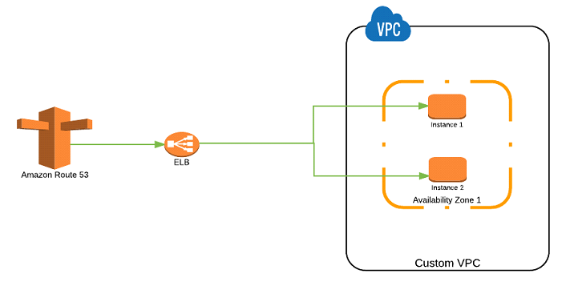

**Use Case for Route 53:**

A step-by-step guide to create an EC2 instance, set up a load balancer, and register a domain with Amazon Route 53:

**Step 1: Create an EC2 Instance:**

1. Log in to AWS Console: Sign in to your AWS Management Console.

2. Launch Instance: Navigate to the EC2 Dashboard and click on "Launch Instances."

3. Choose an AMI: Select an Amazon Machine Image (AMI) for your instance.

4. Choose Instance Type: Choose the instance type based on your requirements.

5. Configure Instance: Configure instance details such as the number of instances, network settings, and storage.

6. Add Storage: Configure the instance's storage settings.

7. Add Tags: Optionally, add tags to help identify your instances.

8. Configure Security Group: Configure security group rules to control inbound and outbound traffic.

9. Review: Review your instance configuration and click "Launch" to create the instance.

**Step 2: Set Up an Application Load Balancer (ALB):**

1. Create Load Balancer: In the EC2 Dashboard, navigate to "Load Balancers" and click "Create Load Balancer."

2. Select Load Balancer Type: Choose "Application Load Balancer."

3. Configure Load Balancer: Configure the load balancer settings, such as name, listeners, and availability zones.

4. Configure Security Settings: Configure security settings and SSL certificates if needed.

5. Configure Routing: Set up target groups to route traffic to your instances.

6. Register Targets: Add your EC2 instances to the target group.

7. Review and Create: Review your settings and click "Create" to create the load balancer.

**Step 3: Register a Domain with Route 53:**

1. Route 53 Dashboard: In the AWS Management Console, navigate to the Route 53 Dashboard.

2. Create Hosted Zone: Click "Create Hosted Zone" and enter your domain name.

3. Copy Name Servers: After the hosted zone is created, you'll get a set of Route 53 name servers. Copy these for use at your domain registrar.

4. Update Domain Registrar: Log in to your domain registrar's website and update the DNS name servers with the ones you copied from Route 53.

5. Create Record Sets: In your hosted zone, create the necessary record sets (A records, CNAME records, etc.) that point to your load balancer and instances' public IP addresses.

6. Testing: Wait for the DNS changes to propagate (which might take some time, 8-15 minutes), and then test accessing your domain in a web browser.

**FAQs:**

Certainly, here are some frequently asked questions (FAQs) about Amazon Route 53:

**1. What is Amazon Route 53?**

Amazon Route 53 is a scalable and highly available domain name system (DNS) web service provided by Amazon Web Services (AWS). It allows you to manage domain registration, DNS routing, and health checking of resources.

**2. What are the main features of Route 53?**

Route 53 offers features such as domain registration, DNS management, routing policies, health checks, alias records, private DNS, integration with other AWS services, and traffic flow.

**3. How does Route 53 improve website availability?**

Route 53 uses health checks to monitor the availability of resources. If a resource becomes unhealthy, Route 53 can automatically route traffic to a healthy resource, improving the overall availability of your application.

**4. What is a hosted zone in Route 53?**

A hosted zone is a container for DNS records that belongs to a specific domain. It holds information about how you want to route traffic for that domain.

**5. What is a TTL (Time to Live) in DNS?**

TTL is a setting in DNS records that specifies how long a DNS resolver should cache the DNS information before it queries the authoritative DNS server again. A shorter TTL allows for quicker changes to propagate but might increase the load on DNS servers.

**6. Can I use Route 53 for routing traffic to resources outside of AWS?**

Yes, Route 53 can be used to route traffic to resources both inside and outside of AWS. You can set up routing policies based on latency, geolocation, weighted distribution, and more.

**7. What is an alias record in Route 53?**

An alias record is a special type of DNS record in Route 53 that allows you to map a DNS name to an AWS resource. It's used for mapping a domain to an AWS resource like an Elastic Load Balancer or an Amazon S3 bucket.

**8. What is latency-based routing in Route 53?**

Latency-based routing is a routing policy in Route 53 that directs traffic to the resource with the lowest latency based on the user's geographical location. This helps improve the user experience by minimizing response times.

**9. How does Route 53 integrate with other AWS services?**

Route 53 integrates with various AWS services like Amazon S3, Elastic Load Balancing, CloudFront, and more. You can use it to route traffic to these resources using domain names.

**10. Is Route 53 suitable for private networks?**

Yes, Route 53 supports private DNS, allowing you to resolve domain names within your Virtual Private Cloud (VPC) without exposing them to the public internet.